This document details the experimental steps for four core Istio traffic management capabilities (Traffic Shifting, Request Routing, Fault Injection, Circuit Breaking) on the Windows system, including key operation commands, verification methods, experimental phenomena and core notes. All operations are adapted to the Windows terminal (PowerShell/CMD), and the experiment is based on the official Istio Bookinfo sample application.
Experimental Environment Preparation
- Basic Environment Requirements
- Basic Environment Requirements
- Windows 10/11 operating system
- Docker Desktop installed (with Kubernetes enabled, Kubernetes 1.24+ recommended)
- kubectl installed and cluster context configured (Docker Desktop comes with kubectl, which needs to be added to the system environment variables)
- Istioctl installed (Istio command-line tool, version 1.20+ recommended)
- Network access to GitHub and the official Istio image repository
- Istio Installation and Initialization
- Download and Install Istioctl
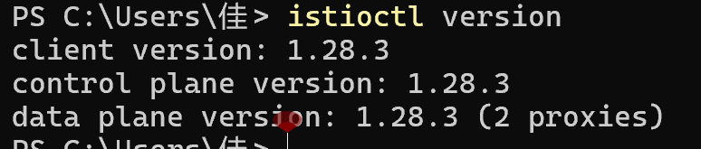
- Deploy Istio to the Kubernetes Cluster
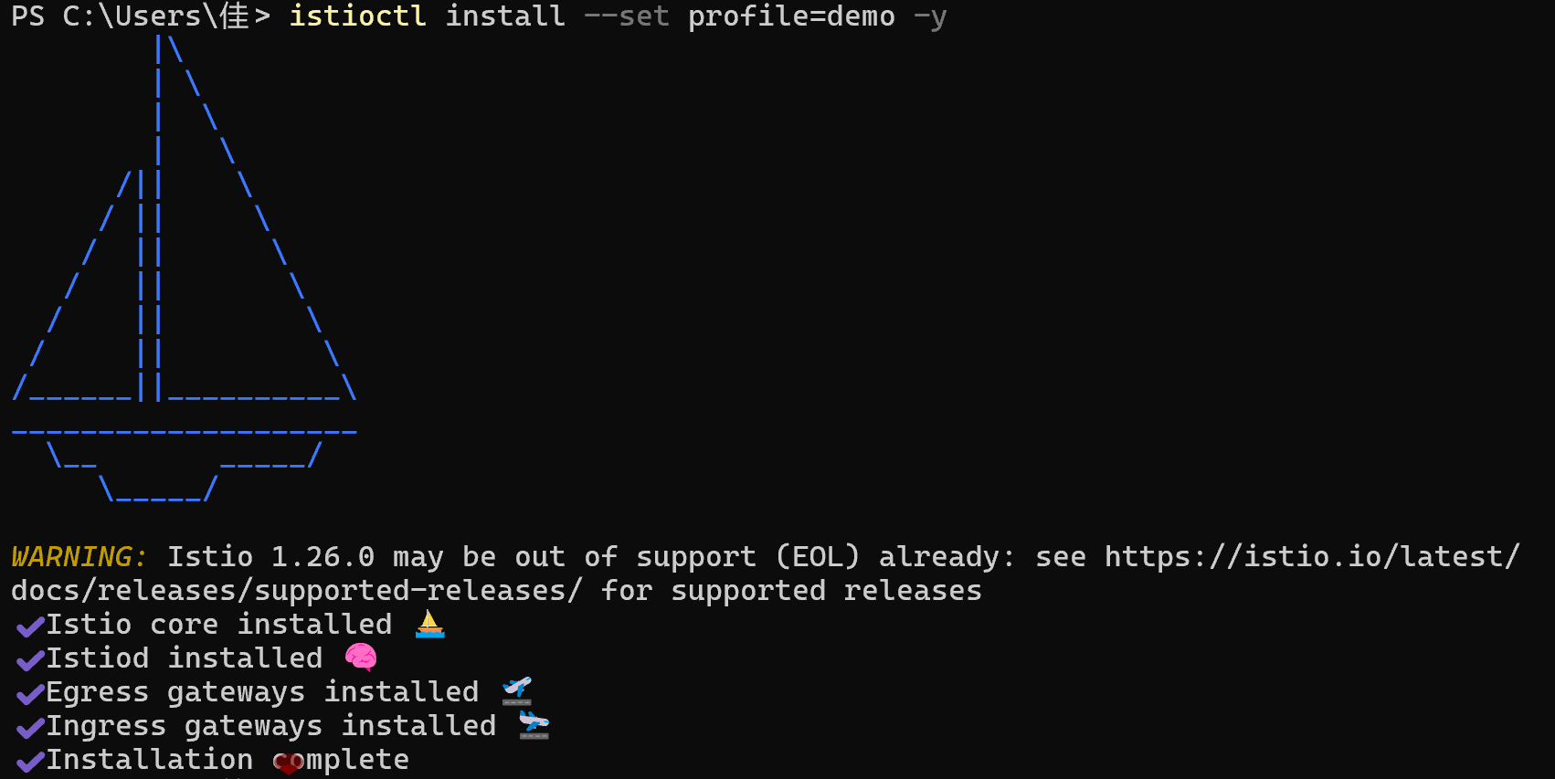
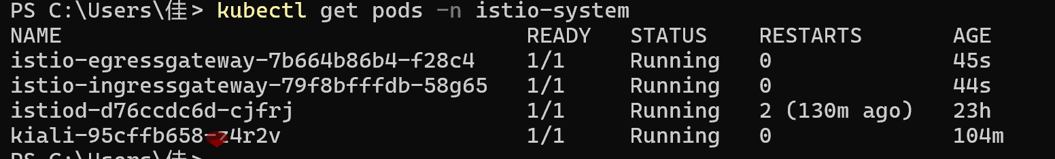
- Enable Automatic Sidecar Injection for the Namespace
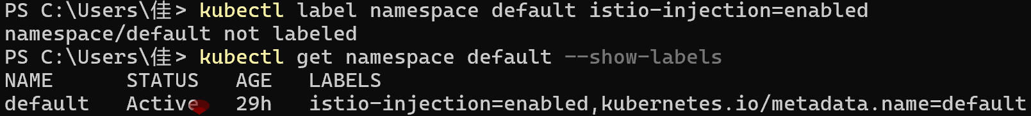
- Deploy the Bookinfo Sample Application
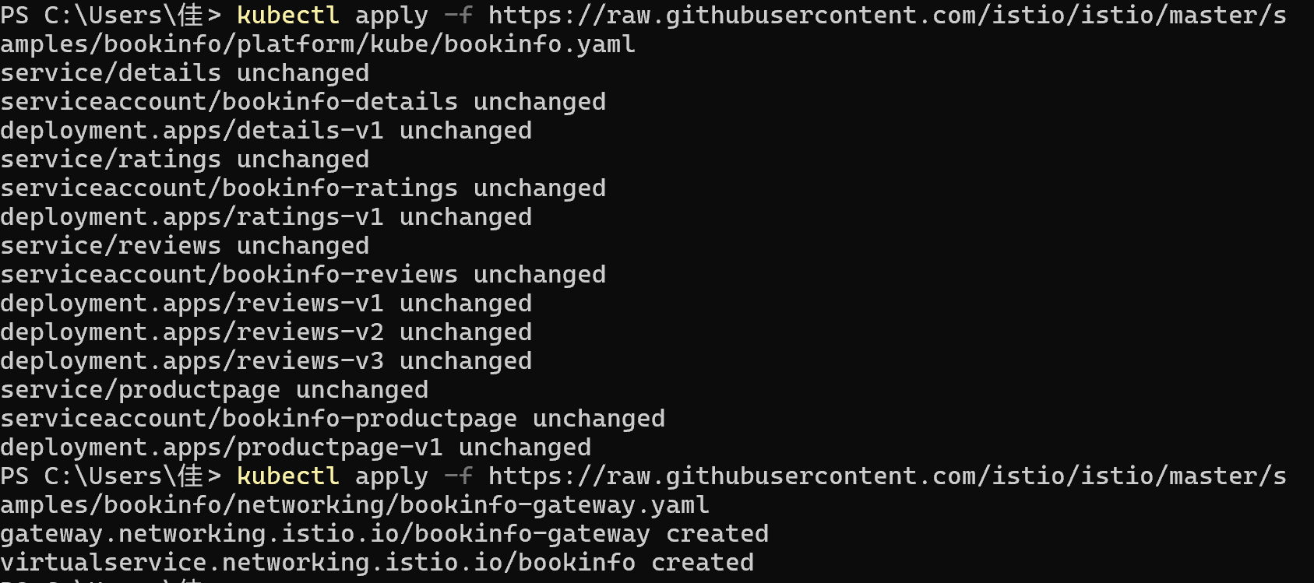
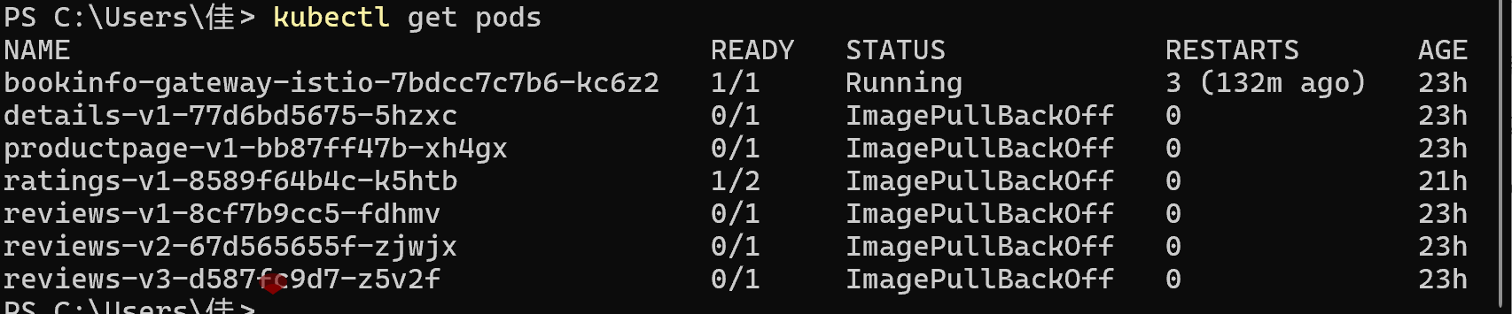
Get Gateway access address
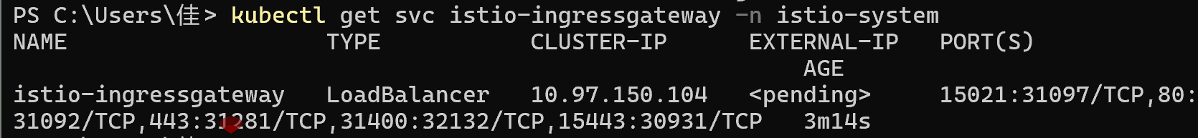

Experiment 1: Traffic Shifting
- Experimental Objective
Realize the gradual migration of traffic from reviews:v1 to reviews:v3 (50%→100%) through weighted routing, and master the core method of Istio canary release.
- Core Principle
Set traffic weights for different versions of the same service through VirtualService. The Istio Sidecar distributes requests according to the weights, enabling imperceptible grayscale without modifying application code.
- Experimental Steps
- Step 1: Route all traffic to reviews:v1
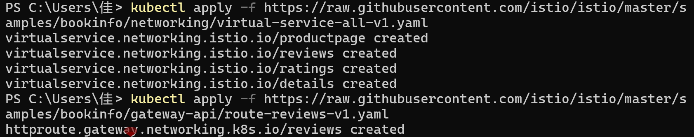
- Step 2: Route 50% of traffic to reviews:v3 and keep 50% on v1
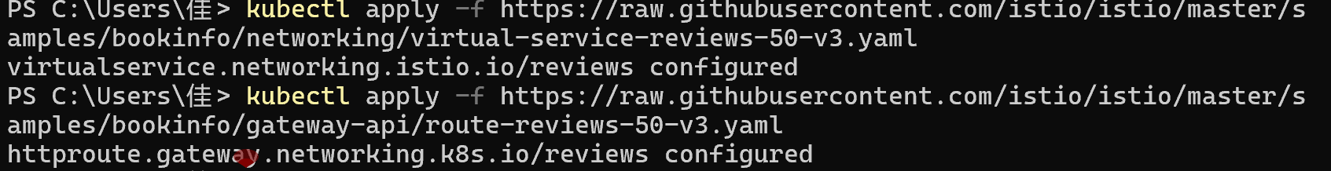
Verify the Rule Configuration
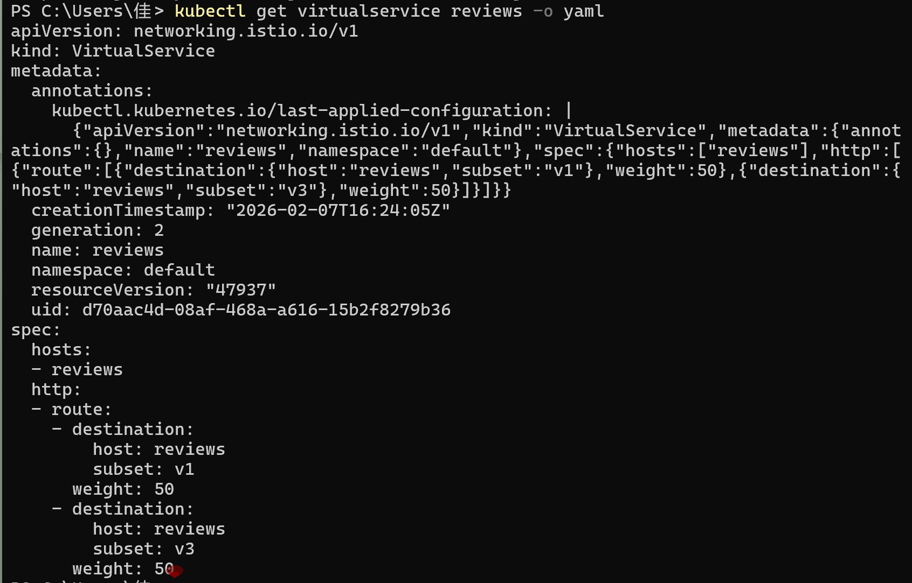

Key Configuration Snippet:
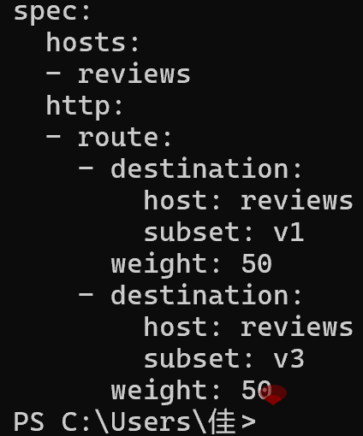
- Step 3: Route 100% of traffic to reviews:v3
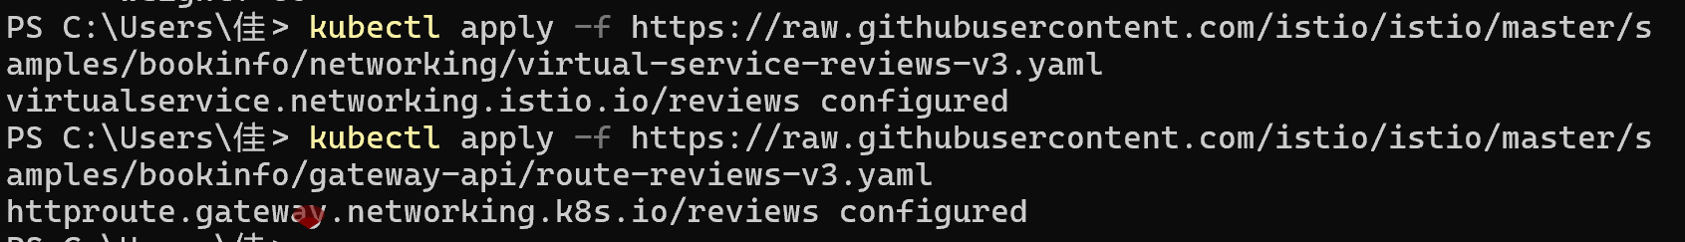
- Experiment Cleanup
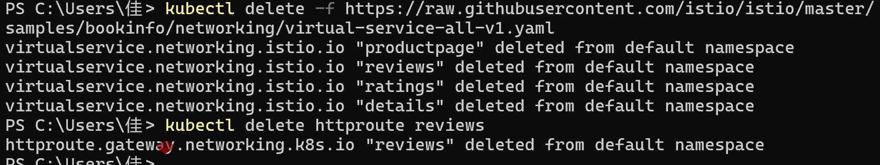

Experiment 2: Request Routing
- Experimental Objective
Implement fixed version routing: Route all traffic to version v1 of all services.
Implement user identity-based routing: Route only the traffic of user jason to reviews:v2, and route the traffic of other users to v1 as before.
- Core Principle
Set routing matching conditions (such as HTTP headers, parameters, user identities) through the match field of VirtualService to achieve refined traffic distribution, suitable for personalized routing by user/scenario.
3. Experimental Steps
- Step 1: Route all traffic to version v1 of all services
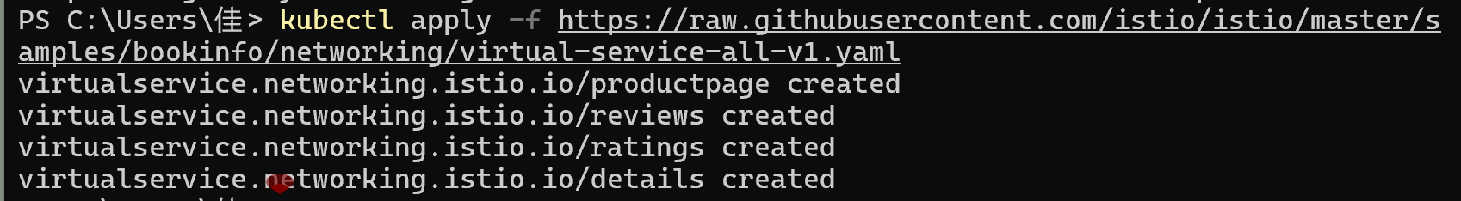
- Step 2: Configure user identity-based routing (jason→reviews:v2)
Verify the Rule Configuration
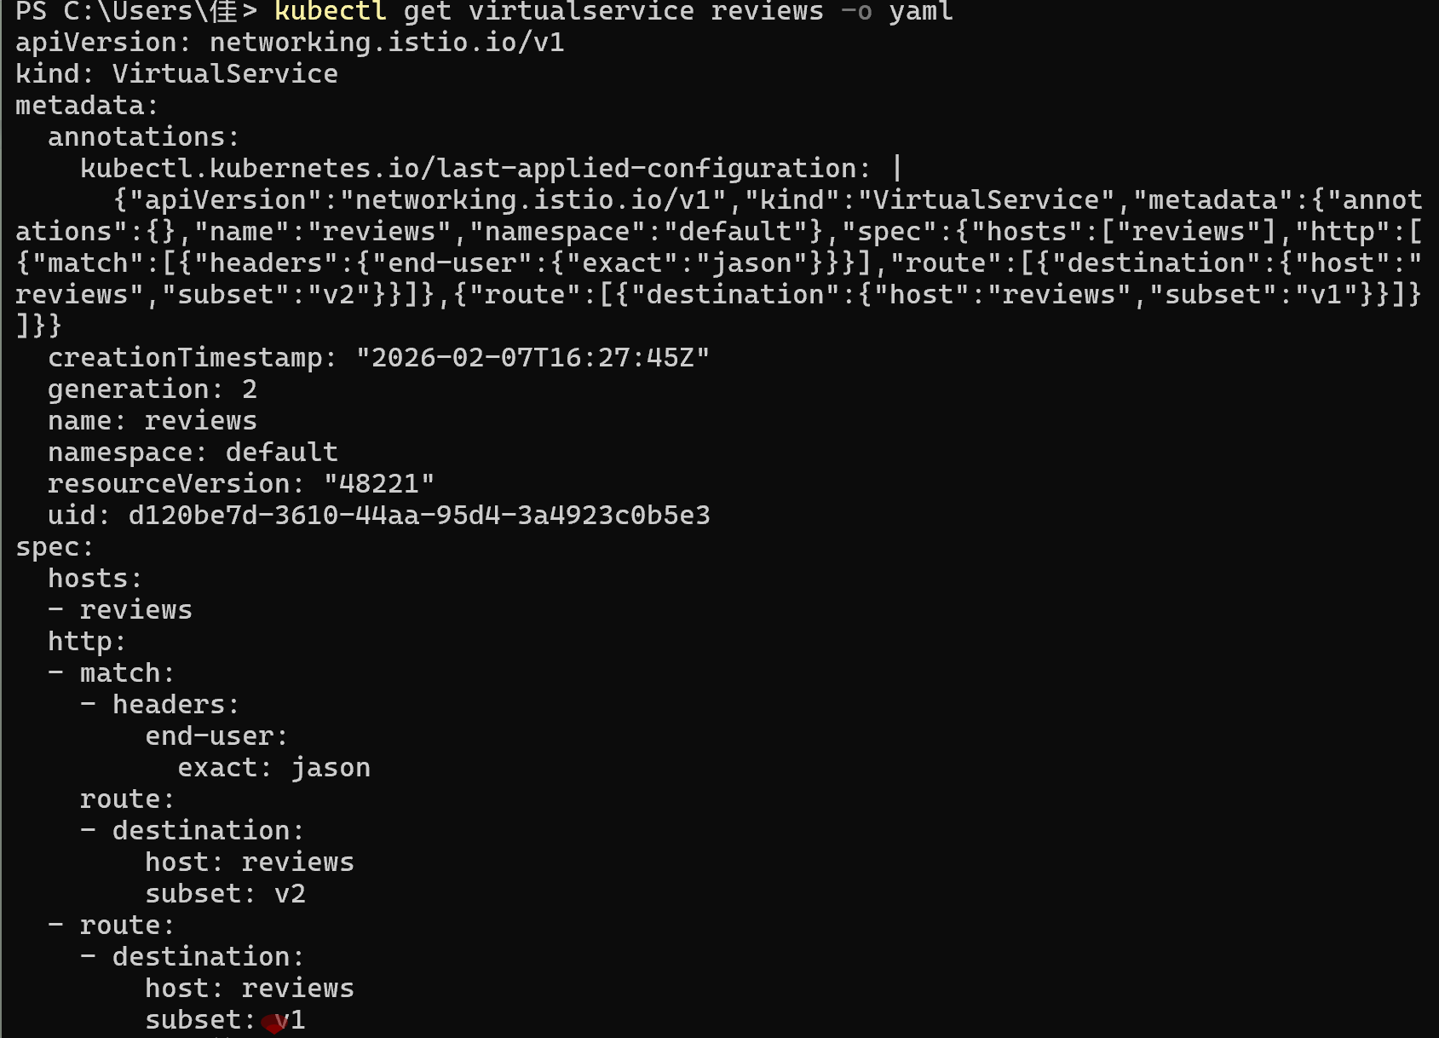

Key Configuration Snippet (matching the end-user: jason header):
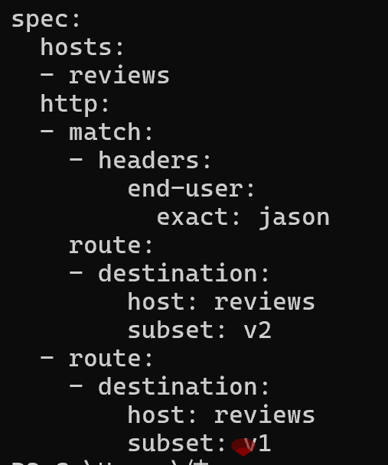
- Step 3: Verify the User-based Routing Effect
- Open http://$GATEWAY_URL/productpage in a browser and do not log in: Refresh multiple times, no stars in the comment section (routed to v1).
- Click Login in the upper right corner of the page, enter the username jason and any password: Refresh the page, black star ratings appear in the comment section (a feature of the reviews:v2 version).
- Log out and log in with another username: The comment section returns to no stars, which is consistent with the routing rules.
- Experiment Cleanup
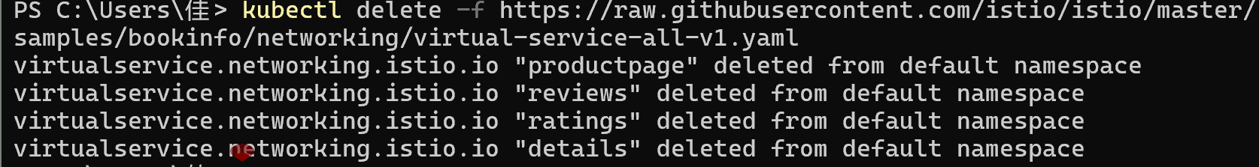

Experiment 3: Fault Injection
- Experimental Objective
Inject an HTTP delay fault: Add a 7s delay to the requests from user jason to the ratings service to find application timeout bugs.
Inject an HTTP abort fault: Inject a 500 error for user jason to test the fault tolerance of the application.
- Core Principle
Inject delay/abort faults through the fault field of VirtualService without modifying application code. Fault testing can be performed on specified users/traffic in the production environment to verify the elasticity of microservices.

- Experimental Pre-configuration
First configure the basic routing rules (consistent with Step 2 of Experiment 2) to ensure:
- The traffic of user jason is routed to reviews:v2 → calls the ratings service.
- The traffic of other users is routed to reviews:v1 → does not call the ratings service.
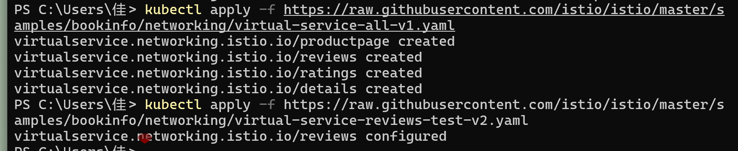
- Experimental Steps
- Step 1: Inject a 7s HTTP Delay Fault (jason→ratings)
Verify the Fault Rule Configuration
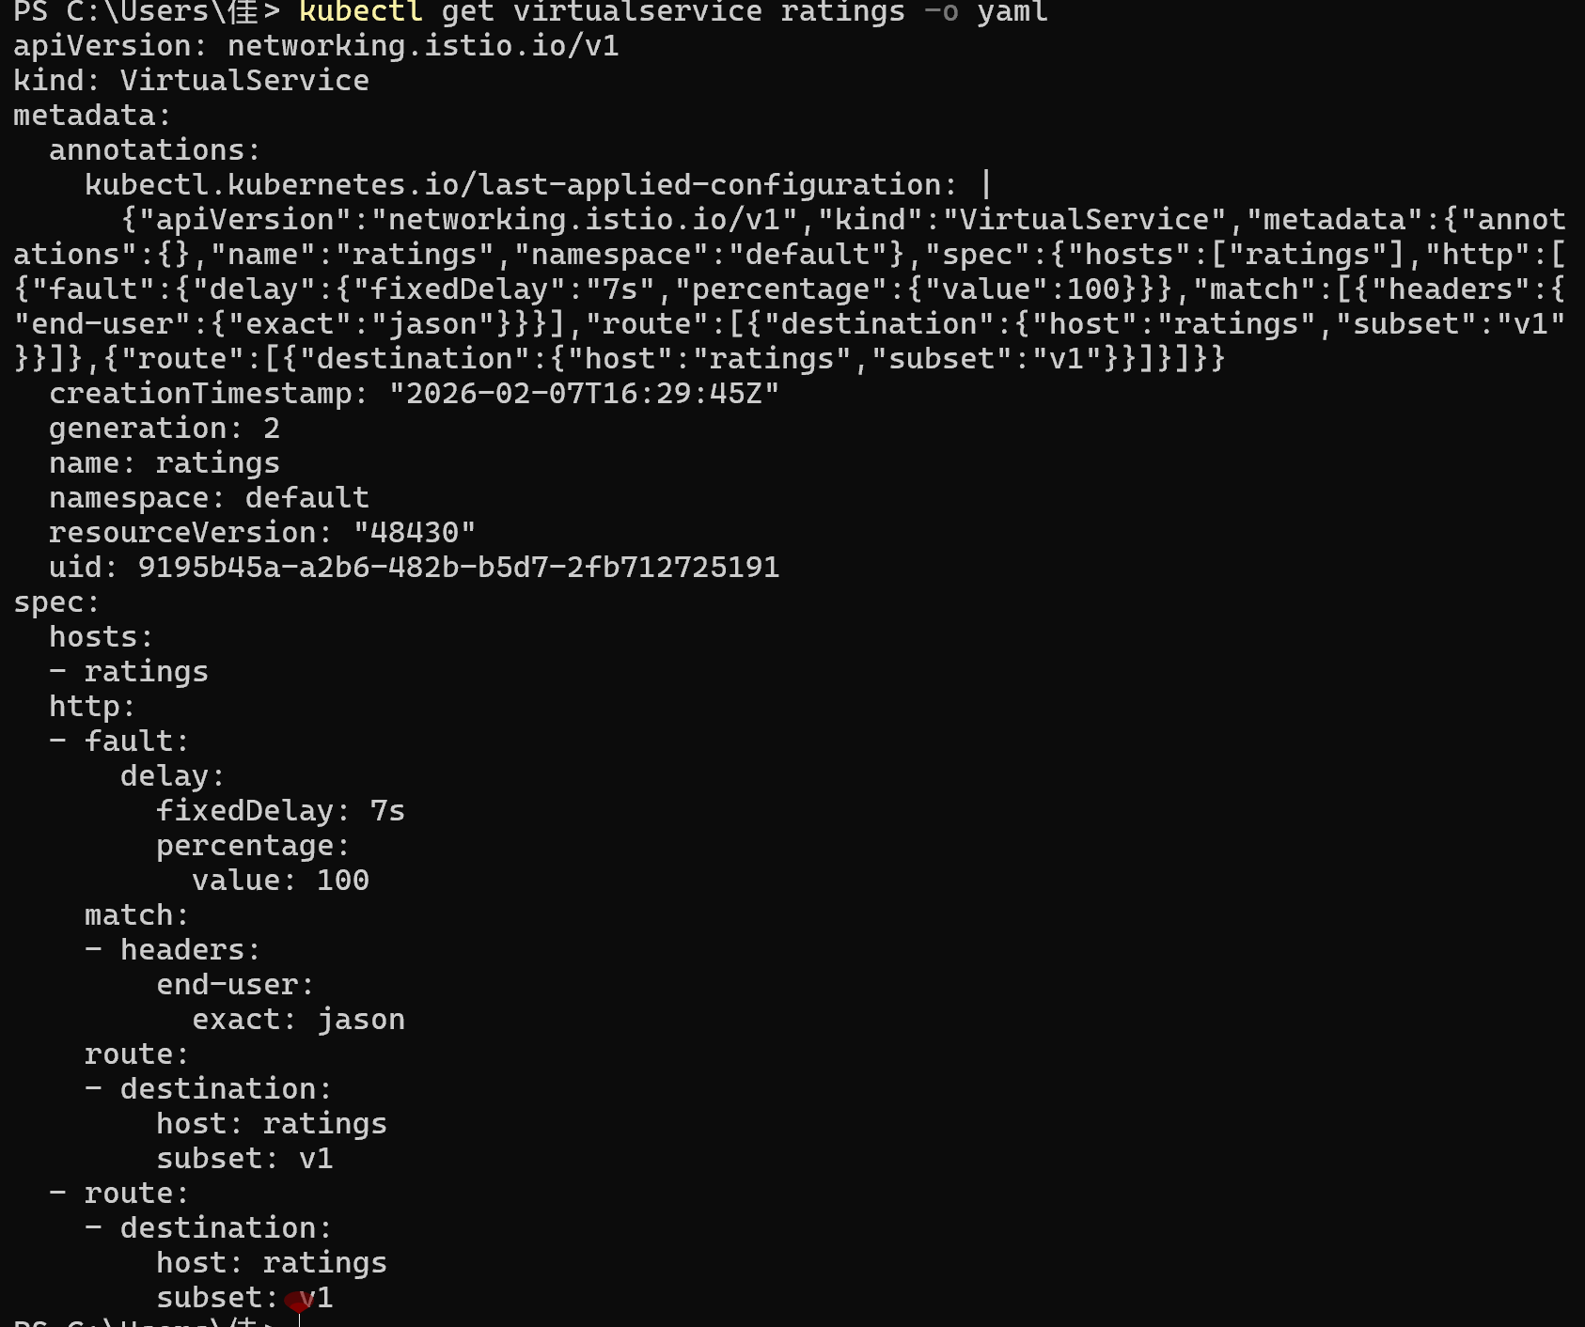
Key Configuration Snippet:
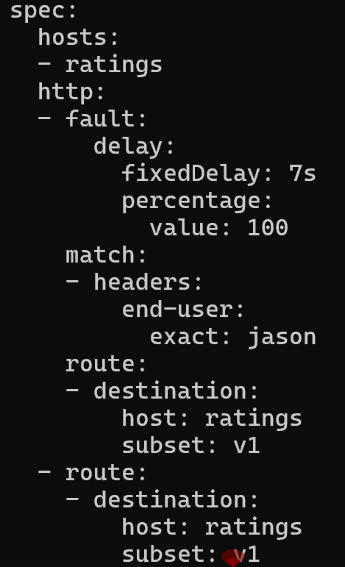
- Step 2: Verify the Delay Fault and Find Application Bugs
- Log in as user jason in the browser and open the product page; an error is displayed in the comment section: Sorry, product reviews are currently unavailable for this book.
- Open the browser Developer Tools (F12)→Network, refresh the page, and find that the page loads completely after 6s.
- Root cause of the bug:
- The timeout setting of reviews:v2 for ratings is 10s, so a 7s delay should work normally.
- However, the timeout setting of productpage for reviews is 3s + 1 retry = 6s, which triggers a timeout in advance and causes an error.
- Log out of jason; the page loads normally with no delay/error (the fault only takes effect for jason).
- Step 3: Fix the Bug (Route to reviews:v3)
- Step 4: Inject an HTTP 500 Abort Fault (jason→ratings)
Verify the Fault Rule Configuration
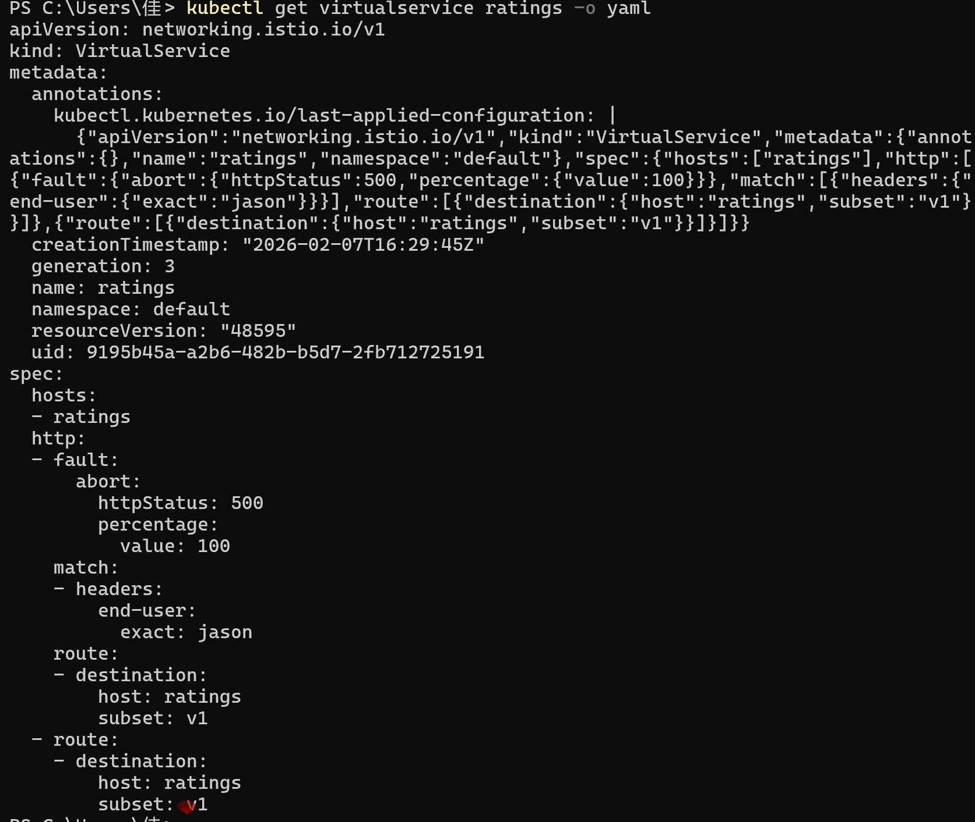
Key Configuration Snippet:
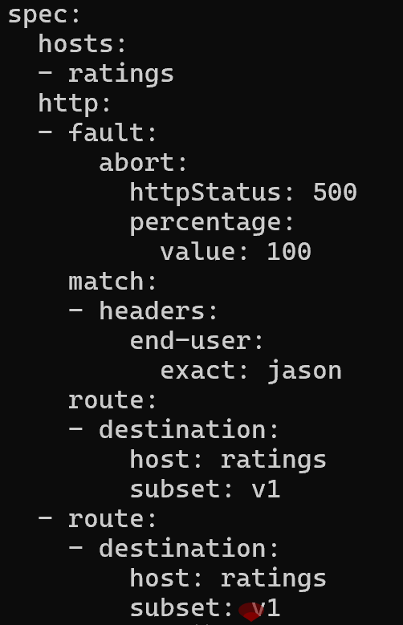
- Step 5: Verify the Abort Fault Effect
- Log in to the browser as user Jason, refresh the product page, the page loads immediately, but the comments section shows 'Ratings service is currently unavailable';
- After logging out, the page returns to normal without any error messages, which is consistent with the fault injection rules.
Experiment Notes:
- Fault injection can set the injection ratio through the 'percentage' field (e.g., 10%) to avoid affecting all traffic;
- The fault injection matching rules are consistent with the request routing, allowing precise targeting of specific users/scenarios/IPs for safe testing in the production environment;
- Microservices timeout configurations need to be aligned upstream and downstream, otherwise bugs like 'timeout inconsistency' in the experiment can occur. Istio fault injection is an efficient way to identify such issues.
- Experiment Cleanup
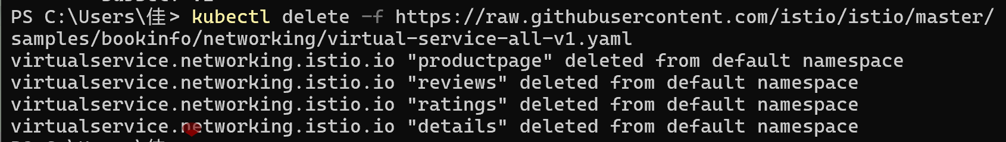

Experiment 4: Circuit Breaking
- Experimental Objective
Configure connection pool and outlier detection rules through DestinationRule, simulate request overload and trigger circuit breaking, and master the configuration and verification methods of Istio circuit breaking.
- Core Principle
- Connection pool limits: Restrict the maximum number of connections and the maximum number of pending requests to the target service to prevent a single service from being overloaded and crashing the entire cluster.
- Outlier Detection: When continuous errors are detected in a service instance, remove it from the load balancing pool and try to restore it after a period of time to achieve fault self-healing.
- Experimental Preparations
This experiment uses the httpbin sample service (instead of Bookinfo); deploy httpbin and the pressure testing tool fortio:
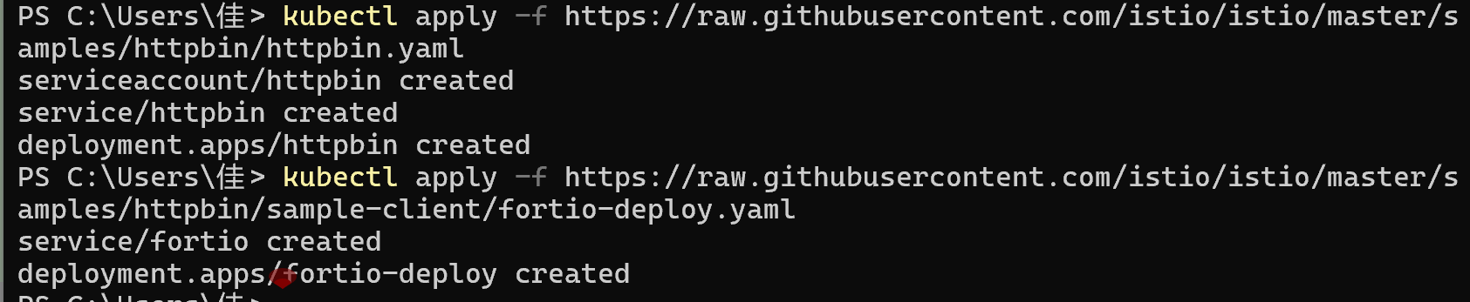
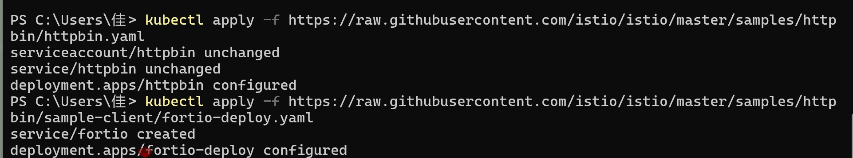
Verify the deployment:
- Experimental Steps
- Step 1: Configure Circuit Breaking Rules (DestinationRule)
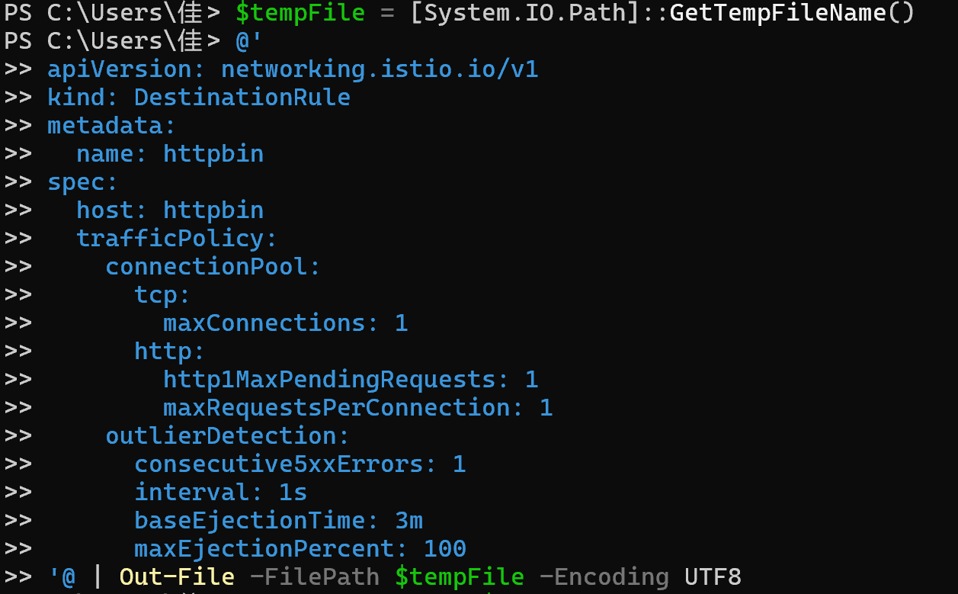
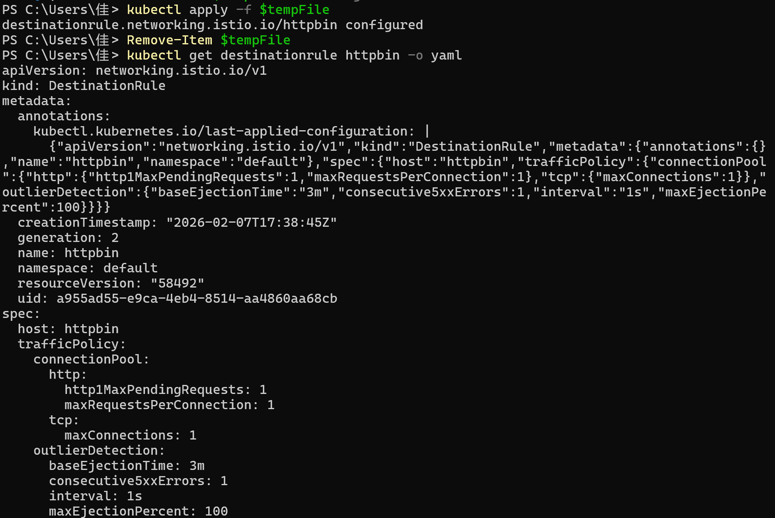
- Step 2: Test Normal Requests (No Circuit Breaking Triggered)
- Step 3: Trigger Circuit Breaking (Multi-concurrent Requests)
- 2 concurrent connections, 20 requests
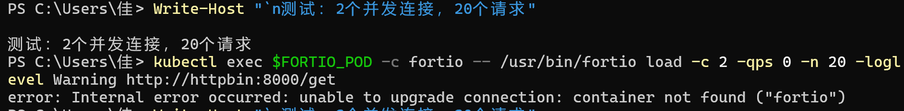
- 3 concurrent connections, 30 requests (more obvious circuit breaking)
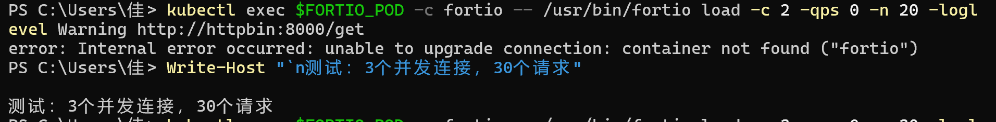

- Step 4: View Circuit Breaking Monitoring Metrics
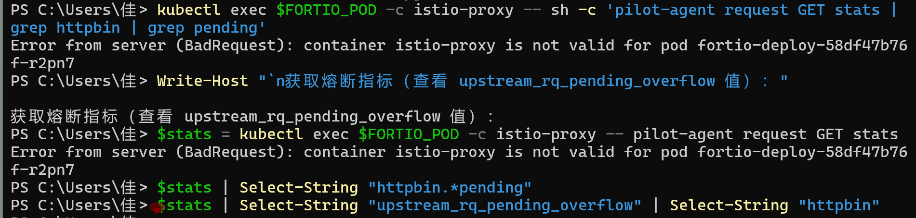
- Experiment Cleanup
